**Monday:**

1. Use the command line to run asciify.py (included in the assignment repo). What does this script do? Include a screenshot of your results.

This script takes an image and turns it into keyboard characters to display the image in terminal.

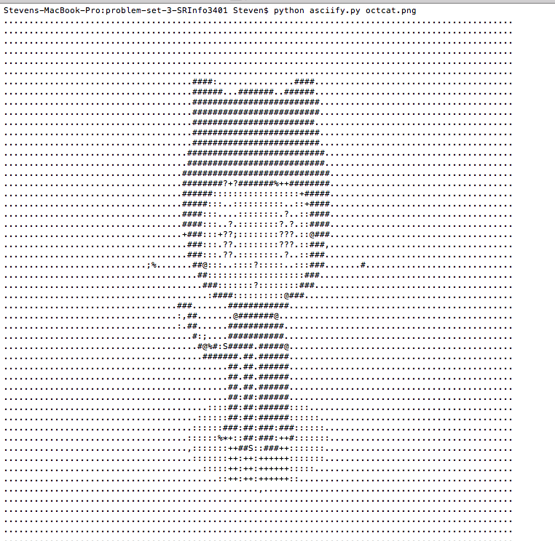

2. Install the Delorean Python package. What command did you use? Then, from the command line, launch Python. Use it to execute the following commands:

Use command “pip install Delorean”

What prints to the command line?

The print statement rendered “Delorean(datetime=datetime.datetime(2018, 9, 11, 16, 44, 40, 393176), timezone='US/Eastern')”

3. Use the command line to download <http://www.colorado.edu/>. What command did you use? Make sure to include this file as part of your submission.

The command line used was “wget <http://www.colorado.edu/>”

4. Search the downloaded file from #3 for the word "Colorado." What command did you use? How many lines did this find?

The command line used was (need to be in correct directory) “grep -ni Colorado index.html | wc -l”

This found 81 lines

5. Now, print the lines containing the word "Colorado" to a file to "search_results.html". What command did you use? Include this file as part of your submission.

The command line used was “grep -n Colorado index.html > search_results.html”

**Wednesday:**

CU has recently come across a variety of findings stating that regular gym attendance can lead to a higher GPA. In an effort to understand this effect and how they might update their services and facilities to encourage students to be active, they want to turn to the data to both understand the current state of gym use, its potential effects on students, and how they might target specific facilities or programs to improve attendance.

First, identify three datasets that CU can provide you to support this effort.

Database 1 : CU student attendee name records

Database 2 : CU rec - Tracks who and how many times a person visits the gym.

Database 3 : CU academic records - Track the users from gym to their current gpa.

Then, use the CoNVO method to scope a project that will solve this problem:

Based on these three beneficial datasets I could produce a easily understandable data model showing how gym use correlates with a students increase in gpa. Using the CoNVO method I can further convey my ideas and use of these databases’. The stakeholders in this example comes down to both the university overall and the students who are registered. The university can use the conducted data to ensure their services are adequate. With good facilities that have proven to increase gpa could further attract future students who will produce further revenue for the university. If the gym services are inadequate students could suffer due to the neglect of data efficient use. Using data effectively will ensure gym projects continue to benefit students overall gpa. I believe in this example the target audience is both students and anyone concerned with the university wealth. Needs that will be addressed to make the data concise and understandable will be effective machine learning programs that clean the data sets. There may also be issues with students who attend the gym to often and don't reflect high gpa’s. These outliers will have to be filtered or explained. If data can easily prove that gym attendance can boost gpa students would get more exercise and it can fix the increased incentive to get exercise. Hopefully results from this data collection and presentation influence more students to attend the gym and overall universities average gpa increases. As mentioned the technology that is needed to address these needs will be smart computer scientist or info scientist who can code machine learning systems and present clear data outputs. When we are done the data will prove gym attendance increases gpa and in turn the gym system and facility can take steps to further serve the students and retain the gpa increase trend. When it comes to who handles the continuous future data it can be the university who can now utilize the data systems in order to monitor their gym service and student success.

**Friday**

PROBLEM 1

1. What was the problem?

Ebola outbreak

2. What data was available?

http://apps.who.int/gho/data/node.ebola-sitrep

Most contagious locations. Where it has spread. How many affected/deceased.

3. What methods were used?

Method for data collection all stemmed from patient database.

Data gathered from medical centers and census bureau information.

4. What did they find?

Data shows the most affected places were Sierra Leone, Liberia, and Guinea. After the outbreak the World Health Organization accounted for 28,646 cases and 11,323 deaths.

5. If you were to tackle the same problem today, what would you do differently and why?

This problem did occur within the last few years and it can still have room for improvement. I think instead of focusing strictly on cases and deaths it would be influential for them to show the rate of spread and the path at which its being transported.

PROBLEM 2

1. What was the problem?

Email popularity increase created flooding in Spam mail.

2. What data was available?

The emails being physically monitored and marked spam by human user interactions gave the machine learning data something to use in order to detect spam mail. This fix was essential to comfortable and efficient use of email platforms.

3. What methods were used?

User data collection. Then the use of AI machine learning to further detect and delete spam without user interactions.

4. What did they find?

They have found users spend less time and feel more productive when using email because they now don't have to filter through spam mail. The email artificial intelligence makes user interface more acceptable.

5. If you were to tackle the same problem today, what would you do differently and why?

If this problem were to occur today I would not only train a spam AI bot but would also deploy a deeper machine learning algorithm that would source the email back to the sender and report the account as spam. This will cut down on the spam accounts and alert others to block certain reported contacts before the spam floods in.

PROBLEM 3

1. What was the problem?

Mother nature destruction

2. What data was available?

Data from weather centers. Humidity, wind speed, doppler radar for cloud monitoring, temperatures, atmospheric pressure and so on.

3. What methods were used?

Compiled data and compared current weather patterns to older recorded mother nature events. When comparing data we can predict the path of devastating mother nature or plan for evacuation based on machine learning predictions.

4. What did they find?

They found good predictions on when mother nature events would occur weather it be a tornado, hurricane, tsunami, earthquakes or anything.

5. If you were to tackle the same problem today, what would you do differently and why?

In today's era we have a much more sophisticated array of technologies to predict and analyze mother nature's wrath. Since we have advanced tech I would not only show the storm path and dates of devastating landfalls but would present a data rendering that shows more precise growth and destruction capabilities through a live map feed. This way people can see exactly how serious storm occurrences are and when they should plan on evacuating.